Test Case 1 - Buy Some Energy Gas (within Available Quanity) - Pass

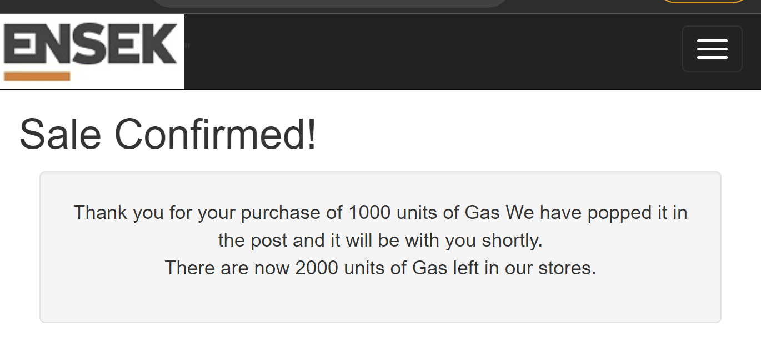

Test Case 2 - Buy Some Energy Electricity (within Available Quanity) - Pass



Test Case 3 - Buy Some Energy Oil (within Available Quanity) - Pass

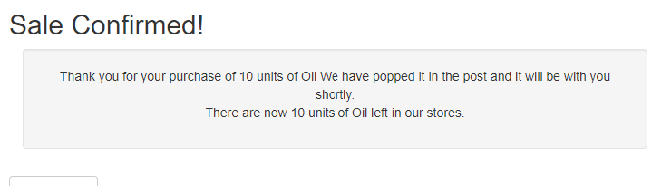

Test Case 4 - Atempt to buy Some Energy Nuclear (within Available Quanity) Pass

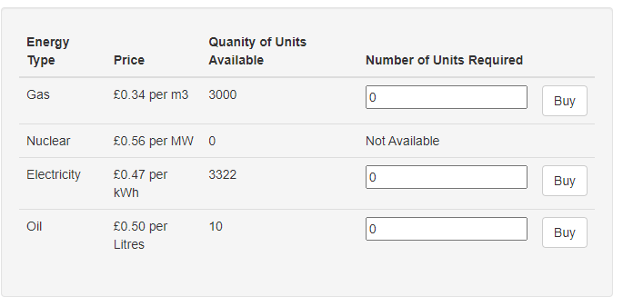

Test Case 5 - Buy all Available units of energy for an energy type - Pass



Test Case 6 - Buy Some Energy (Exceeding the available Quanity) - Fail



Test Case 7 - Buy Some Energy (Add non-numerial char to unit text box) - Fail

Ideally when buy is selected a message should appear under the input field indicating the input format is incorrect

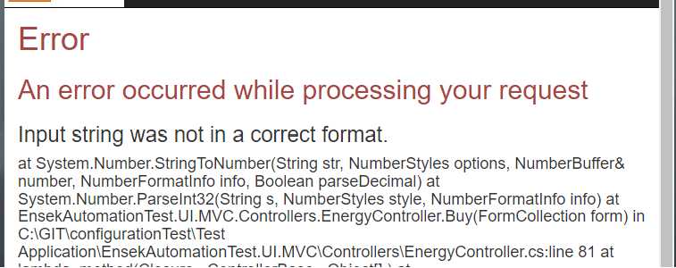

Test Case 8 - Buy Some Energy (Leave unit text box blank) - Fail

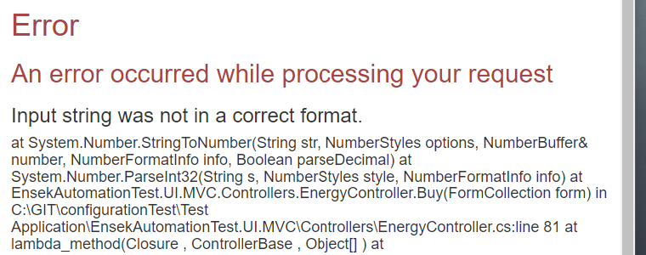

Test Case 9 - Buy Some Energy (Units 0) - Fail

Ideally you shouldn’t be able to purchase 0 unit, and when you try to a message should appear indicating its an invalid value

